Linux Programming | Lab V

Sree Krishna Theja B

17MIS1004

Exercise 1:

Code:

in the given code there is a compilation error i.e, intmain , we can’t proceed further with this error so cange it to int main.

#include <stdio.h>

/\* Print the sum of the integers from 1 to 1000 \*/

int main(int argc, char \*\*argv)

{

int i;

int sum; sum = 0;

for(i = 0; i -= 1000; i++)

{ sum += i; }

printf("%d\n", sum);

return 0;

}

Output:

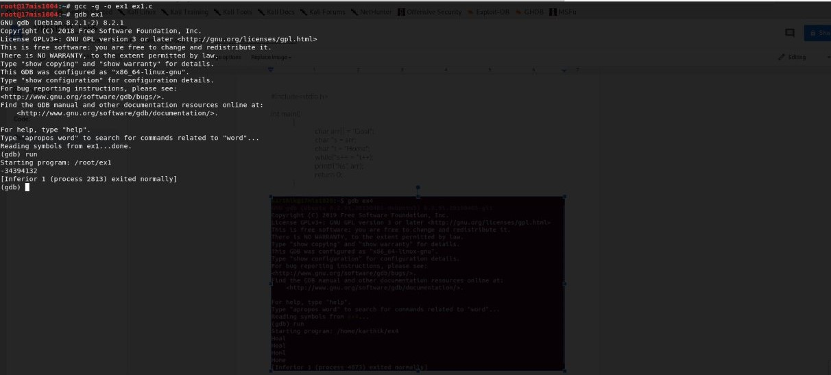

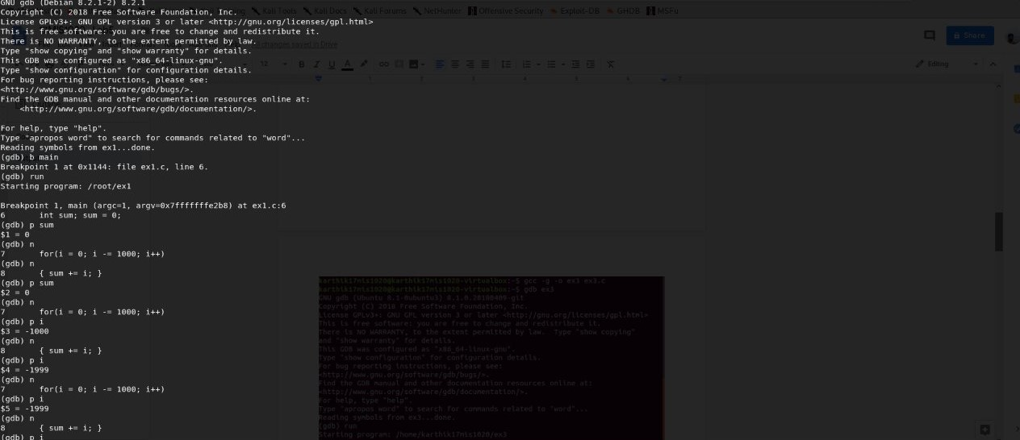

Theres is a error in for loop , so after correcting : The code is

for(i = 0; i <= 1000; i++)

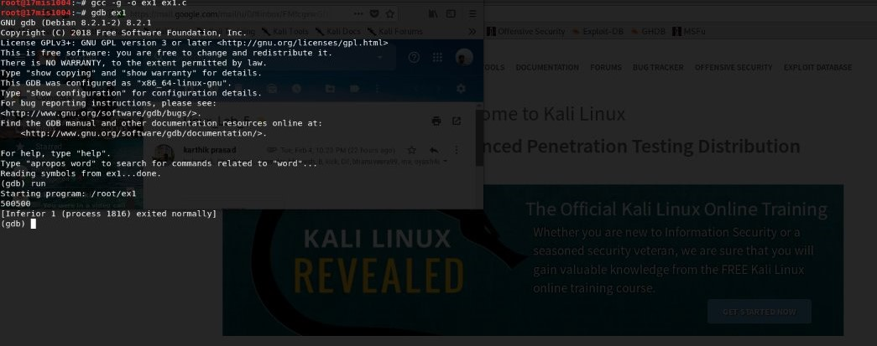

Exercise 2:

Code:

#include<stdio.h>

int main()

{

char \*s = “Goal”;

char \*t = “Home”;

while(\*s++ = \*t++)

printf(\*s);

return 0;

}

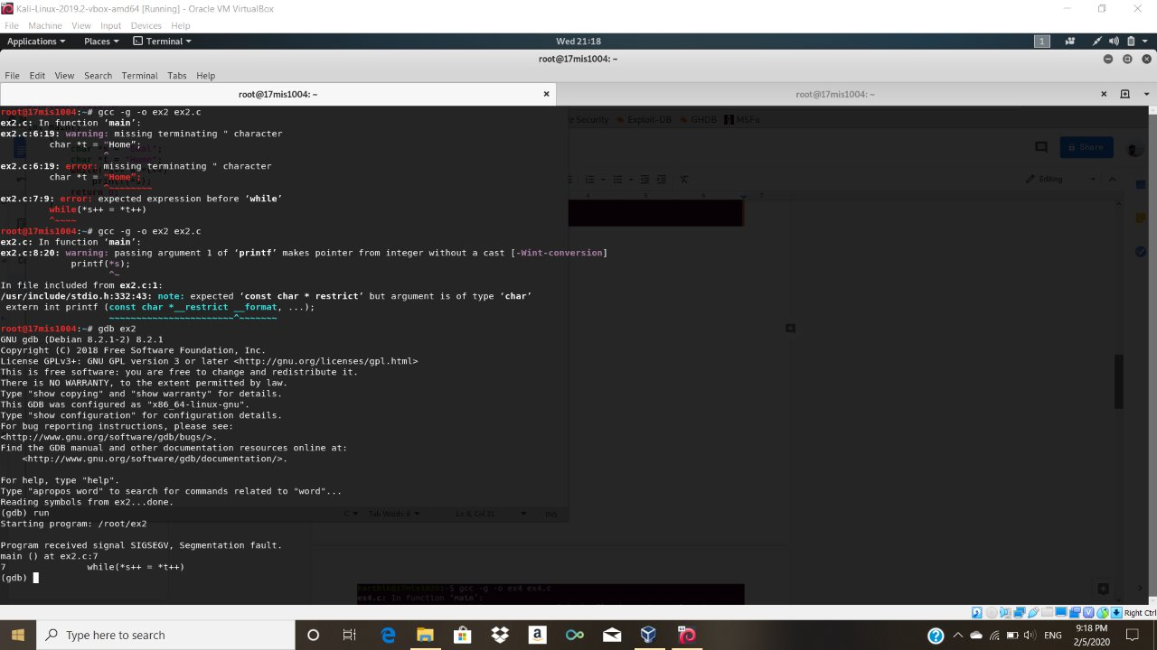

We need to change the string to char array to avoid segmentation fault

char arr[] = "Goal";

char \*s = arr;

